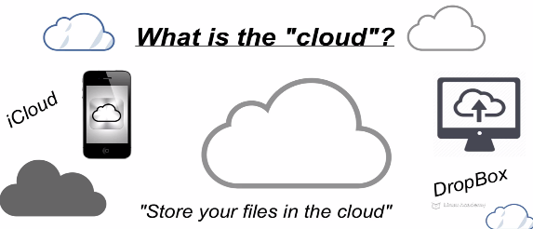

Nooo…..When we upload pics, it will float around in Cyber Space.

What it is???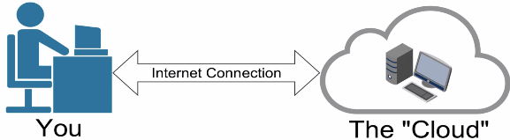

Lets think of a computer(phone) somewhere else.. Access…USING its processing power using Internet connection.

In real it’s like DATACENTER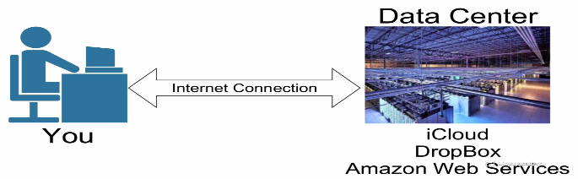

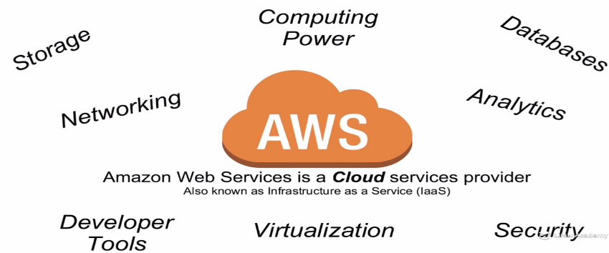

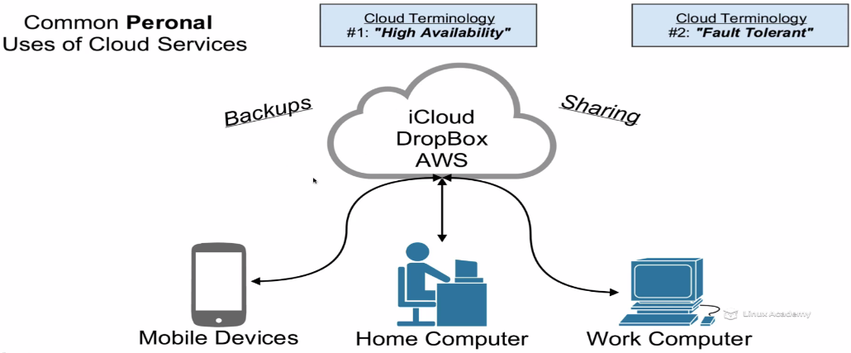

1. **HA**: Files are available ..Anytime across devices, locations..
2. **Fault Tolerance:** If there is fault on HDD or mobile, we can access files. Files are never deleted

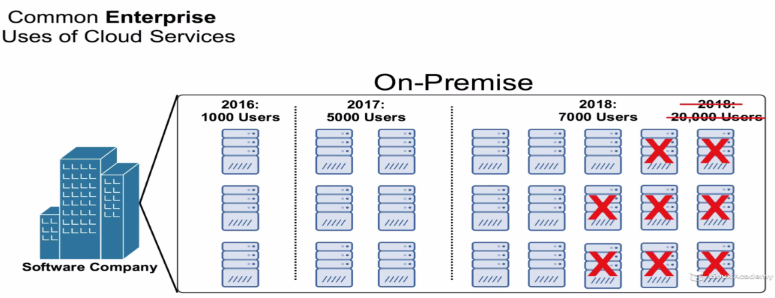

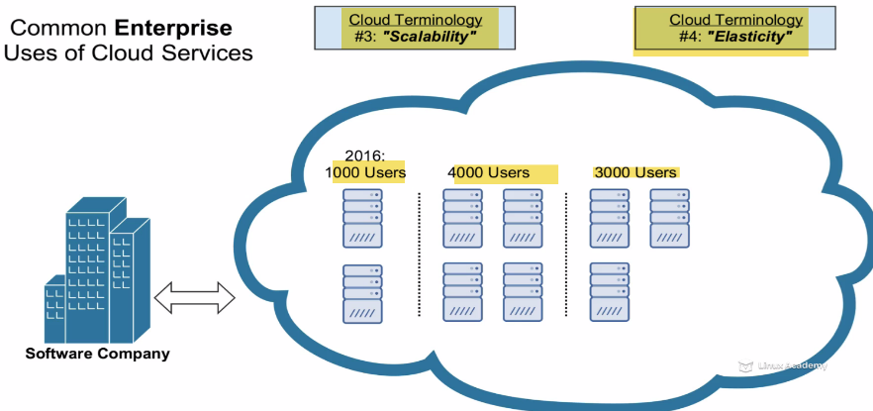

**Scalability**: As userbase goes, we can quickly add servers as needed. Scale up extremely easily.

**Elasticity**: You can also grow, as well as shrink **ON-DEMAND** (rubber band).

3000-4000 users, 4000to 3000 users.

**Understanding VPC**

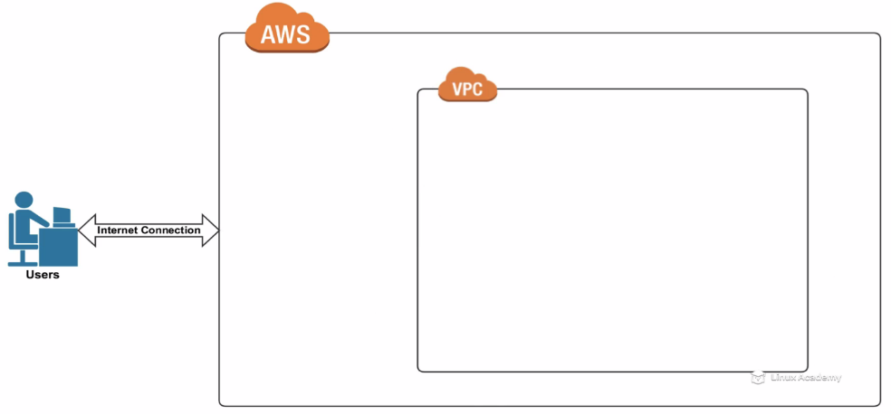

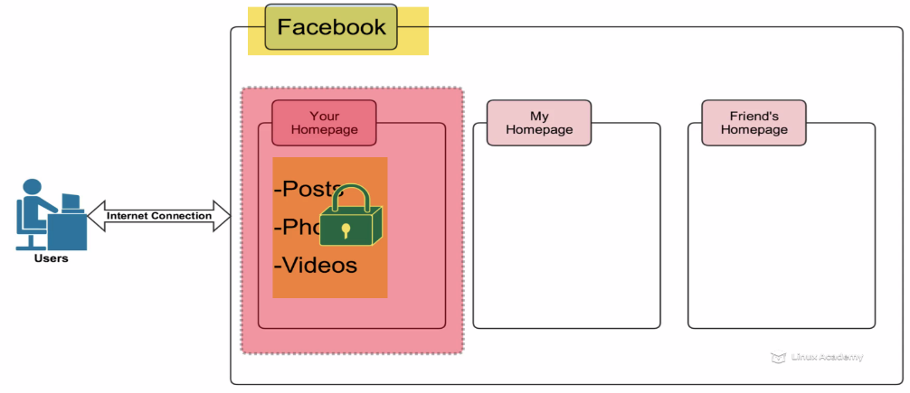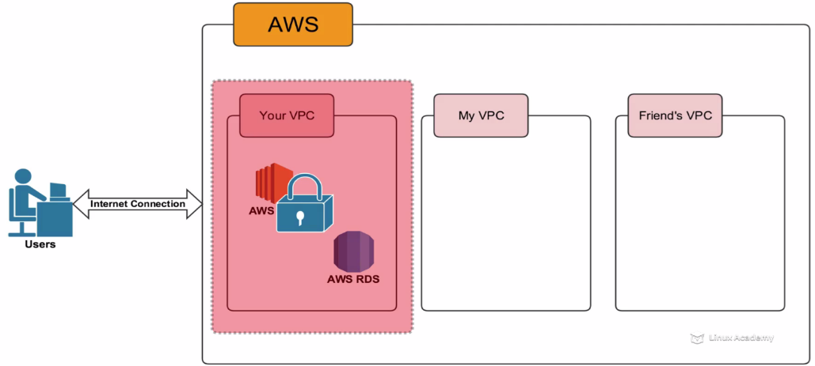



**Understanding EC2**

Netfilx number 1 provider of video stream content. It is No=1 customer of AWS

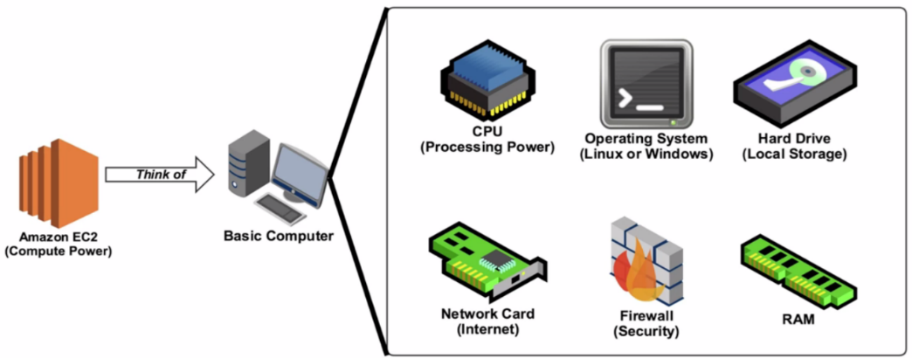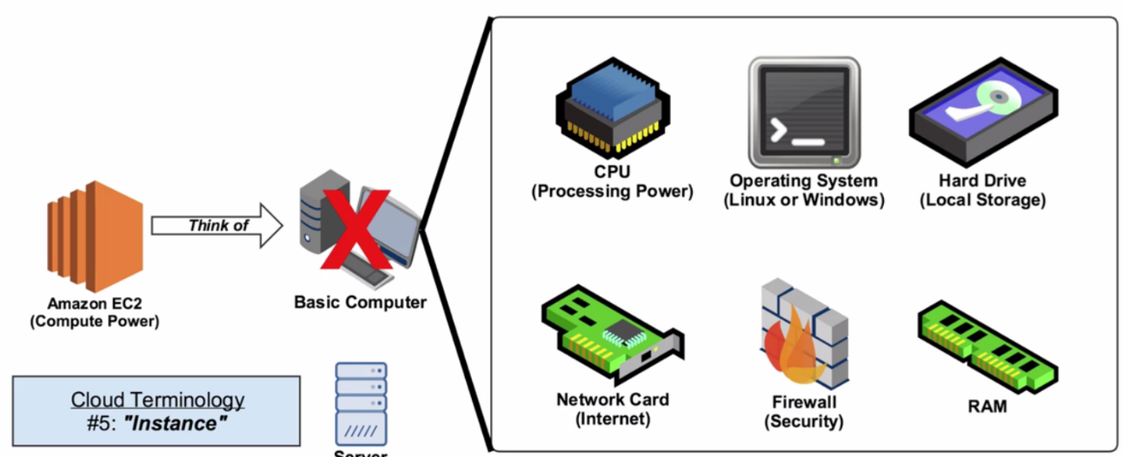

**How does Netflix Uses EC2??**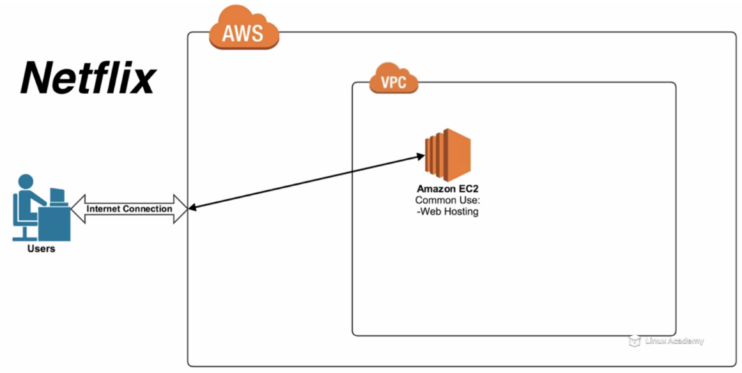



**84-706-3 - Understanding RDS**

Now, what happens when you signin to Netflix???



We create login or enter credentials. Something has to be done with your info. Here, RDS(DB) come into play.

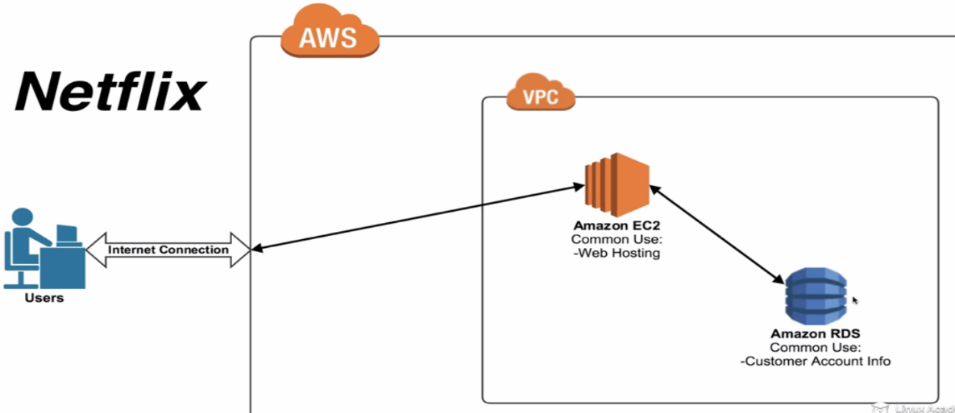

RDS is DB used to store customer info.

Just shrinking diagram: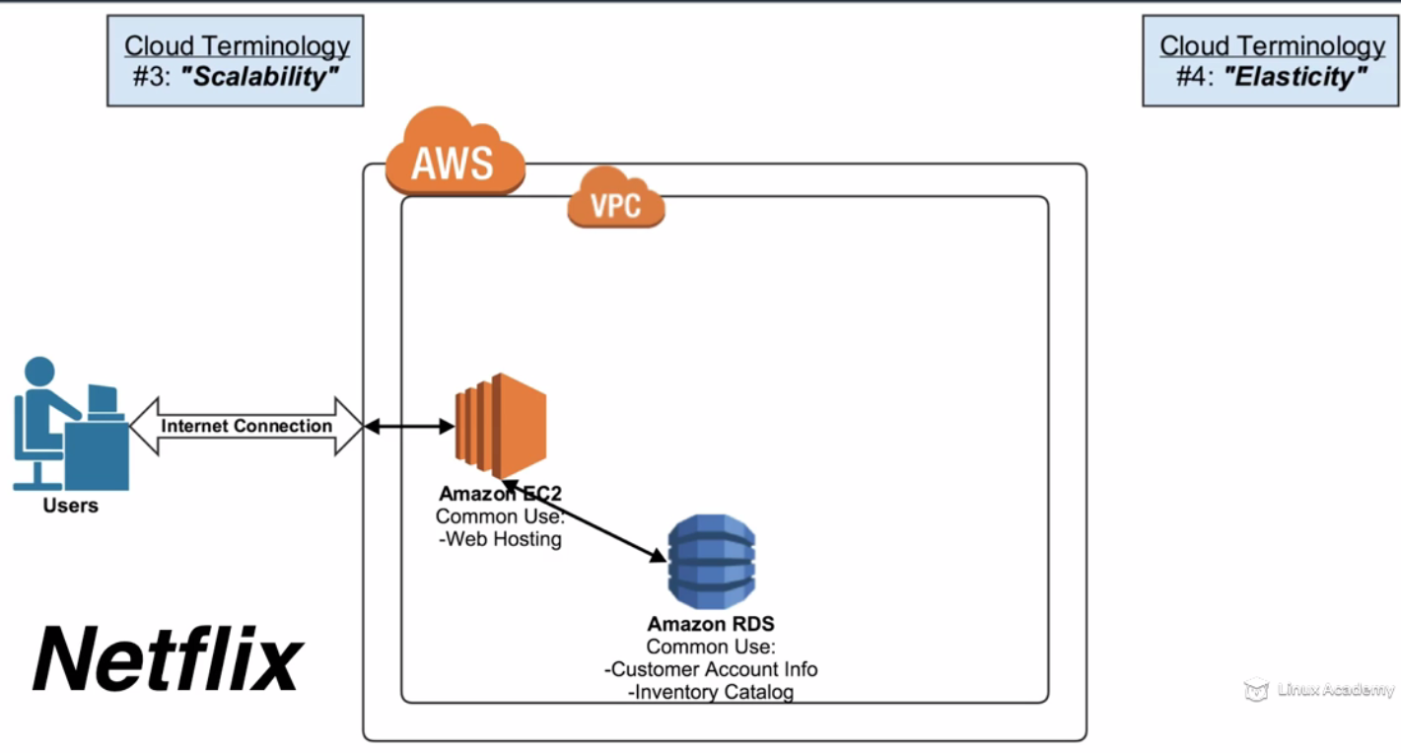

**Scalability:** Lets say User picture means 1000 users. Netflix gets its most users after 8pm, they want to watch tv…After 8pm more users, 8:30 more, 9:00 more,,9:30 –5 times more users currently accessing than 7 pm..

So for more users are trying to use your software, need more servers.

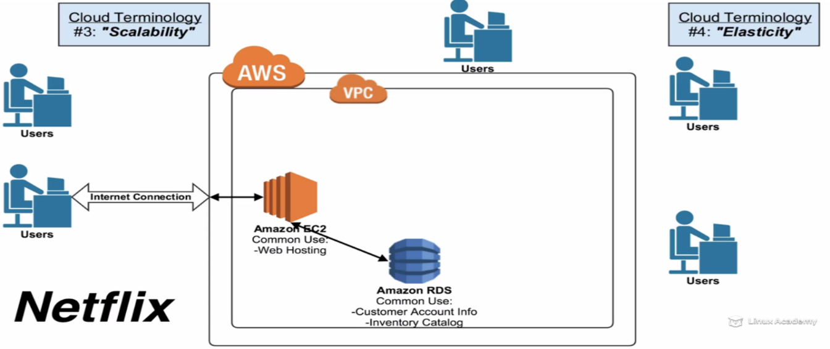

If server is on-premise and didn’t have ability to add more servers on-demand. May be they need to add order, install may take weeks. So, all users will be hitting 1 server. As server can handle only certain amount of traffic. So, if too many people hitting server.. server will crash…THEN nobody can access 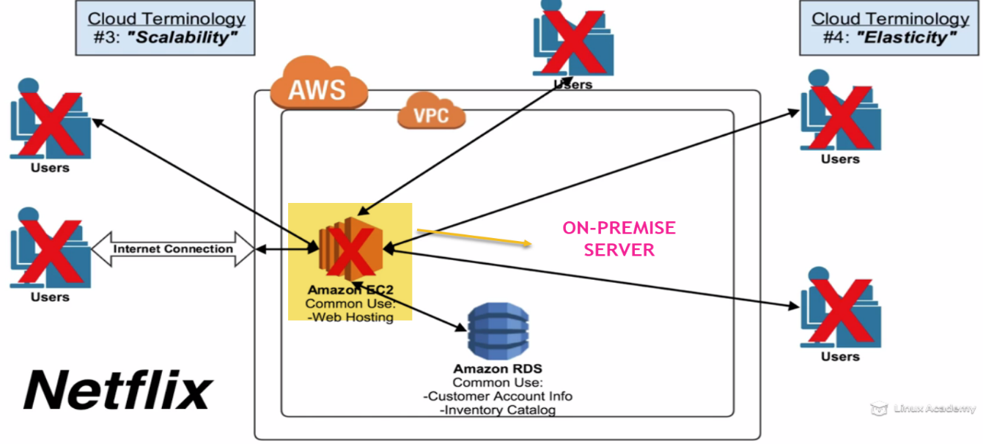

(NO SCALABILITY , ELASTACITY HERE)

Beautiful thing about cloud is, as people load increases from 8pm to 9:00, AWS will automatically add another Ec2 instance to handle those users.

Even if users double or triple AWS will automatically add Ec2 instances inside VPC.. to handle users without being overloaded 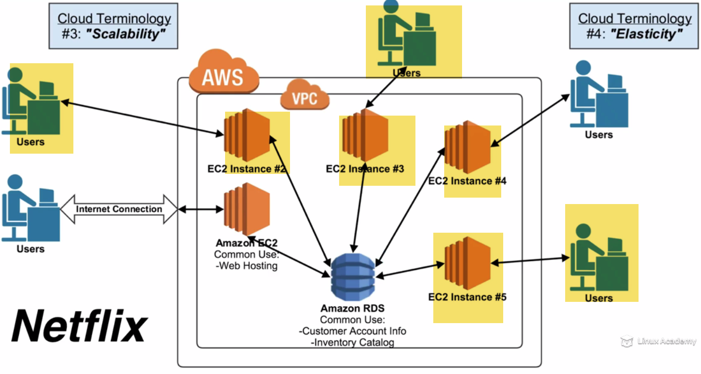

All these Instances can talk to Database, and all users can login..

**Elasticity:** As users drop off at 11:00pm, now Ec2 will be terminated from VPC. No longer need to pay for them

**HA:** Always be available, Access files from anywhere.

As users are added up, new Ec2 instances are provisioned. So Netflix.com is always Available. So here due to scalability and elasticity, Netflix.com is highly available

**Fault tolerance:** If there is any break, we still can access files.

Lets say Ec2 instance# 3 crash. So all users using this instance will no longer access Netflix.

Now, great thing about cloud is: it will redirect users to EC2 instance #2..Assuming instance 2 can handle double load. In most cases it can.

AWS will decommission Ec2#3 and automatically launch new one in its place. Users will be directed to EC2#3 now.

(WHEN THERE IS FAULT IN INSTANCE RIGHT HERE, without erroring out will connect to EC2#2,a nd connect to same databse.SO they can get same info. Seamlessly.

AWS will create new instance and redirect users.

**RECAP**

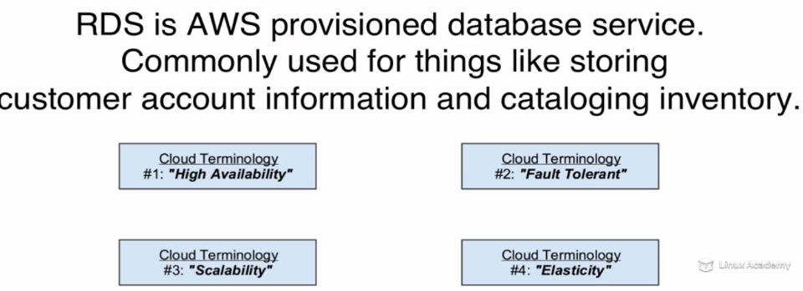

**Understanding S3**

Where Netflix store tons of thousands of their video files (petabytes of files) **(UNLIMTED/massive STORAGE bucket, with HA)**

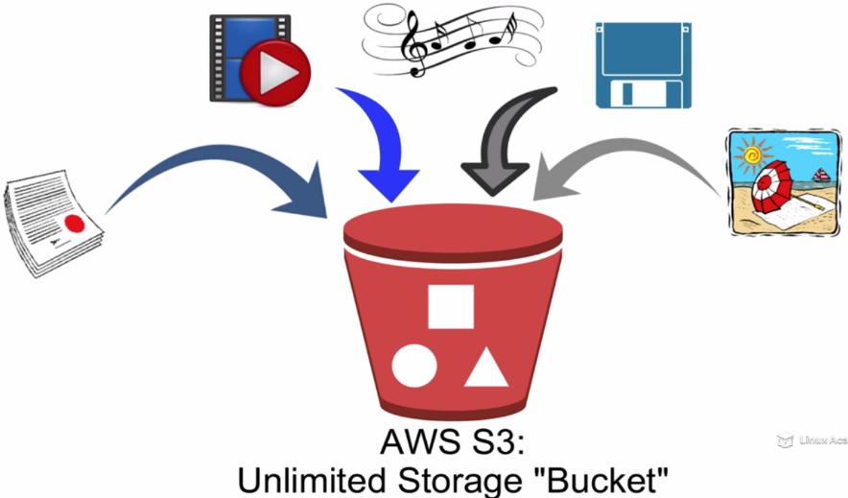

Dropbox is actually a nice user interface that is backedup with S3.

So if we use dropbox, you will actually putting file into S3.

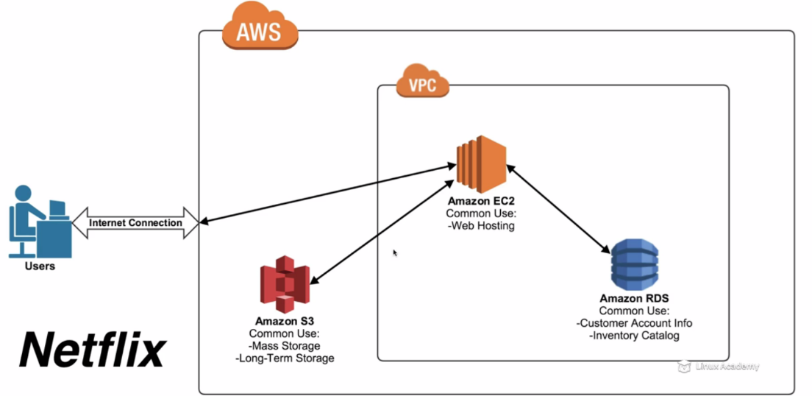

**Understanding EC2**

What happens when hit play video on tv episodes???

Ec2 comes back into play..Ec2 have processing power that is for S3 storage, RDS for info.

When user hits play.., Netflix have to go to S3.., find that particular file or movie.. Pull that file and then on Ec2 instance they may going to encode or transcode that movie or piece of data.. Down to user through internet. Then it can view on their devices.

**Quick:** Amazon Ec2 is very good for any time of processing activity like web-hosting or encoding or transcoding or graphically intensive..

**Introduction to Global AWS:**

How AWS is setup and physically deployed across globe.

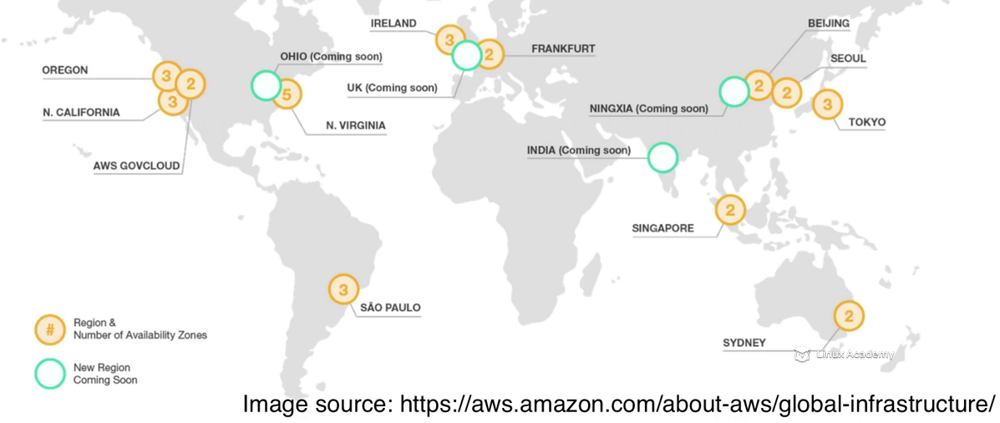

Location of AWS regions.

Each Region is a geographical area. A collection of AWS availability zones and Data Centers.

If a user is in Tokyo, and want to use provision Ec2 instance. They want to launch EC2 instance on physical hardware ..ie., datacenter on Tokyo. Because they want physical hardware to be closer and lot more latency while transmitting Data.

If they want to use Ec2 instance on N.Virgina, Any data they want to sent Back and forth have to travel half way around world back. This takes lot more time and latency.

AWS to provide best absolute performace have put regions, Datacenter and physical hardware all around globe.

Currently 11 active consumer based regions with 1 GOVT based region (AWSGOVCLOUD) .---2016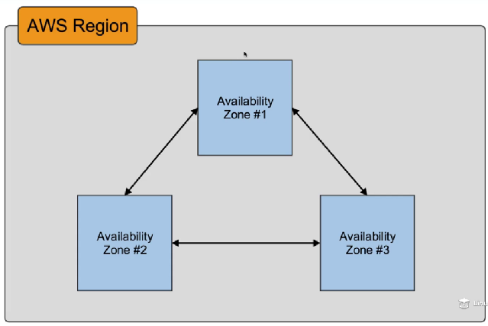 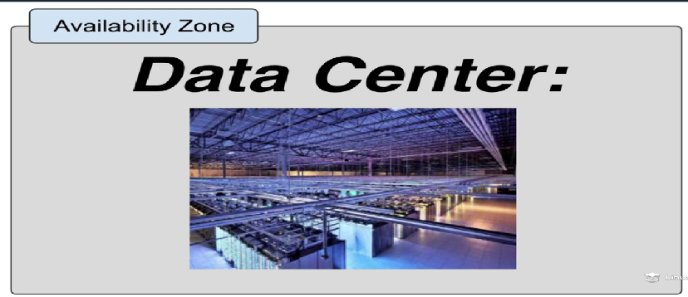

AZ: Geographical physical location that hold AWS DataCenter. Physical AWS Datacenter where all AWS resourses in a data form is located. Each AZ is physically separated from other.

Why they have different AZs in a region???/

For HA and Fault tolerance. Let’s say there is a natural disaster Earth Quake or power Outage in North Virginia.Within regions, there is redundancy b/w AZ.

If AZ1 goes down, most of your files would be already backed up on AZ2 and AZ3 in that particular region.

So, if nothing knocks out entire region..then you should be still access AWS resources(files or info ) uploaded in AWS.

AZ:

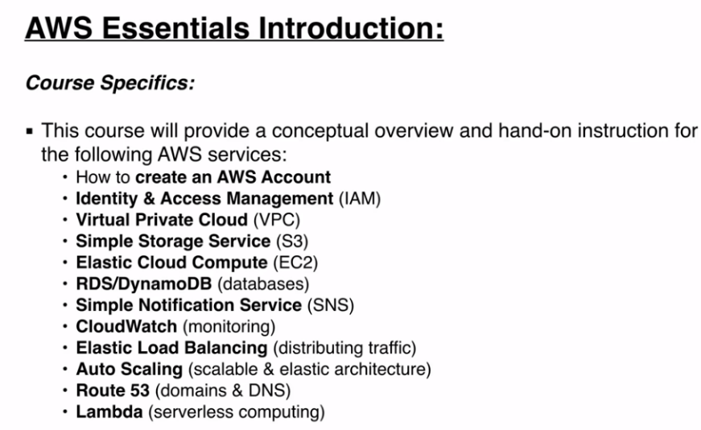 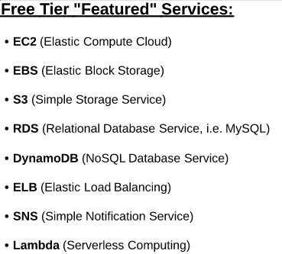

AWS Free Tier (12 Month Introductory Period):

These free tier offers are only available to new AWS customers, and are available for 12 months following your AWS sign-up date. When your 12 month free usage term expires or if your application use exceeds the tiers, you simply pay standard, pay-as-you-go service rates (see each service page for full pricing details). Restrictions apply; see [offer terms](https://aws.amazon.com/free/terms/?ft=nt) for more details.

Elastic Compute Cloud (EC2)

* 750 hours of [Amazon EC2](https://aws.amazon.com/ec2/) Linux t2.micro instance usage (1 GiB of memory and 32-bit and 64-bit platform support) – enough hours to run continuously each month*
* 750 hours of [Amazon EC2](https://aws.amazon.com/ec2/) Microsoft Windows Server† t2.micro instance usage (1 GiB of memory and 32-bit and 64-bit platform support) – enough hours to run continuously each month*
* 750 hours of an [Elastic Load Balancer](https://aws.amazon.com/elasticloadbalancing/) shared between Classic and Application load balancers, 15 GB data processing for Classic load balancers, and 15 LCUs for Application load balancers*
* 30 GB of [Amazon Elastic Block Storage](https://aws.amazon.com/ebs/) in any combination of General Purpose (SSD) or Magnetic, plus 2 million I/Os (with EBS Magnetic) and 1 GB of snapshot storage*
* 500 MB-month of [Amazon Elastic Container Registry](https://aws.amazon.com/ecr/) storage for new customers*

Amazon Simple Storage Service (S3)

* 5 GB of [Amazon S3](https://aws.amazon.com/s3/) standard storage, 20,000 Get Requests, and 2,000 Put Requests*

Amazon Elastic File System (EFS)

* 5 GB per month of [Amazon EFS](https://aws.amazon.com/efs/) capacity free*

Amazon Relational Database Service (RDS)

* 750 hours of [Amazon RDS](https://aws.amazon.com/rds/) Single-AZ db.t2.micro Instances,for running MySQL, PostgreSQL, MariaDB, Oracle BYOL or SQL Server (running SQL Server Express Edition) – enough hours to run a DB Instance continuously each month*
* 20 GB of database storage, in any combination of RDS General Purpose (SSD) or Magnetic storage
* 10 million I/Os (for use with RDS Magnetic storage; I/Os on RDS General Purpose (SSD) storage are not separately billed)
* 20 GB of backup storage for your automated database backups and any user-initiated DB Snapshots

Amazon Cloud Directory

* 1GB of storage per month*
* 10,000 write requests per month*
* 100,000 read requests per month*

Amazon Connect

* 90 minutes per month of Amazon Connect usage*
* A local direct inward dial (DID) number for the AWS region*
* 30 minutes per month of local (to the AWS region) inbound DID calls*
* 30 minutes per month of local (to the AWS region) outbound calls*
* For US regions, a US toll-free number for use per month and 30 minutes per month of US inbound toll-free calls*

Amazon GameLift

* 125 hours per month of Amazon GameLift c4.large.gamelift On-Demand instance usage*
* 50 GB EBS General Purpose (SSD) storage*

Data Transfer

* 15 GB of data transfer out and 1GB of regional data transfer aggregated across all AWS services*

Amazon Data Pipeline

* 3 low frequency preconditions running on AWS per month*
* 5 low frequency activities running on AWS per month*

Amazon ElastiCache

* 750 hours of [Amazon ElastiCache](https://aws.amazon.com/elasticache/) cache.t2micro Node usage - enough hours to run continuously each month.*

Amazon CloudFront

* 50 GB Data Transfer Out, 2,000,000 HTTP and HTTPS Requests of [Amazon CloudFront](https://aws.amazon.com/cloudfront/)*

Amazon API Gateway

* 1 Million API Calls per month*

Amazon Sumerian

* 50MB published scene that receives 100 views per month for free in the first year*

Amazon Elasticsearch Service

* 750 hours per month of a single-AZ t2.micro.elasticsearch instance or t2.small.elasticsearch instance*
* 10GB per month of optional EBS storage (Magnetic or General Purpose)*

Amazon Pinpoint

* 5,000 free targeted users per month*
* 1,000,000 free push notifications per month*
* 100,000,000 events per month*

AWS OpsWorks for Chef Automate

* 7500 node hours (which equals 10 nodes) per month*

AWS OpsWorks for Puppet Enterprise

* 7500 node hours (which equals 10 nodes) per month*

Amazon Polly

* 5 million characters per month*

AWS IoT

* 250,000 messages (published or delivered) per month*

Amazon Lex

* 10,000 text requests per month*
* 5,000 speech requests per mo

And more….

IAM

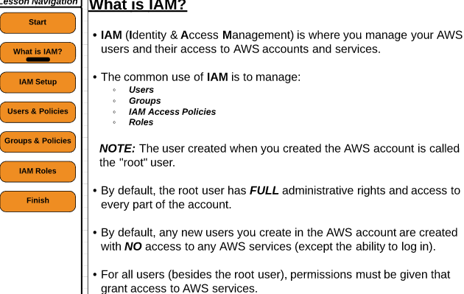

New User will have Zero Permissions…

Root user: Where we entered our Credit card.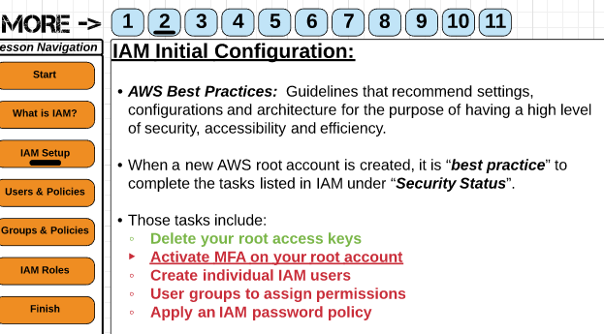 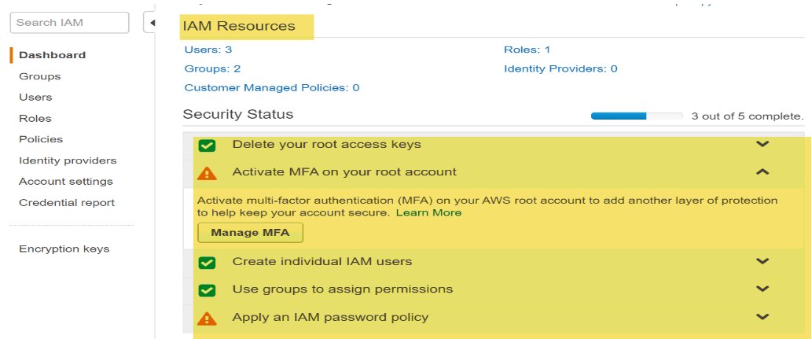

a.)

)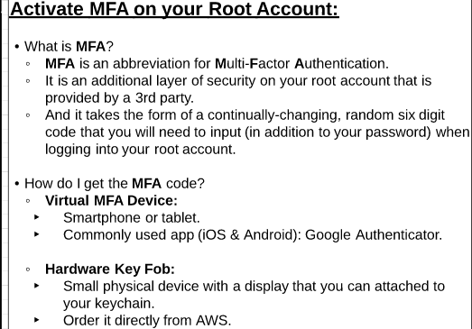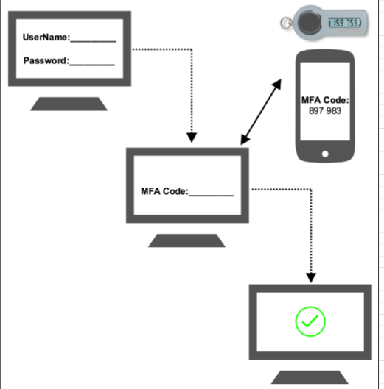

To activate a virtual MFA device, you must first install an AWS MFA-compatible application on the user's smartphone, PC, or other device.(EX: GOOGLE AUTHENTICATOR)..

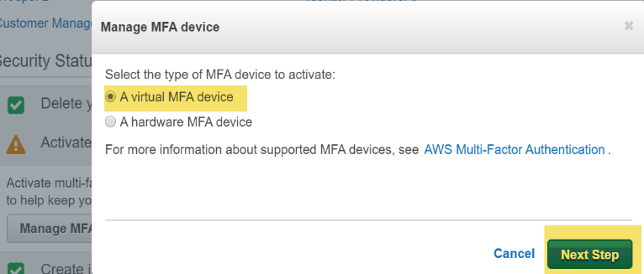 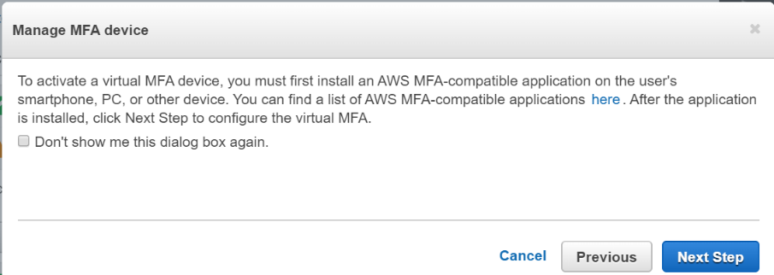 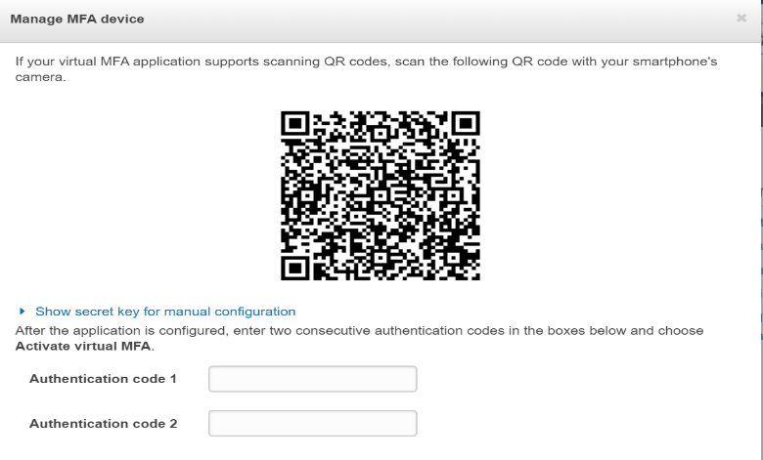 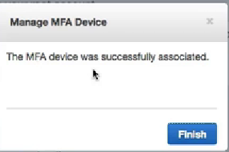

Scan it using Mobile. Authentication codes rotate in 10 sec to get presented..

**b.) Create individual IAM users:** 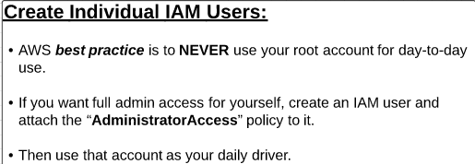

Never use AWS root a/c for daily uses..Create a New IAM user, and give admin rights.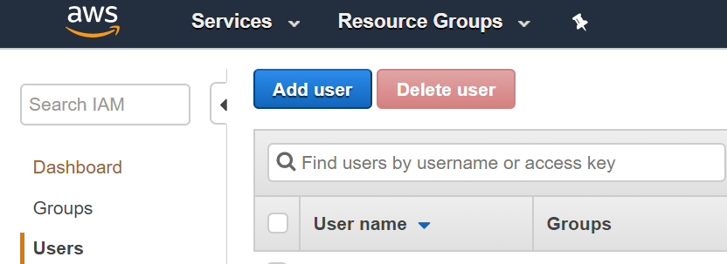 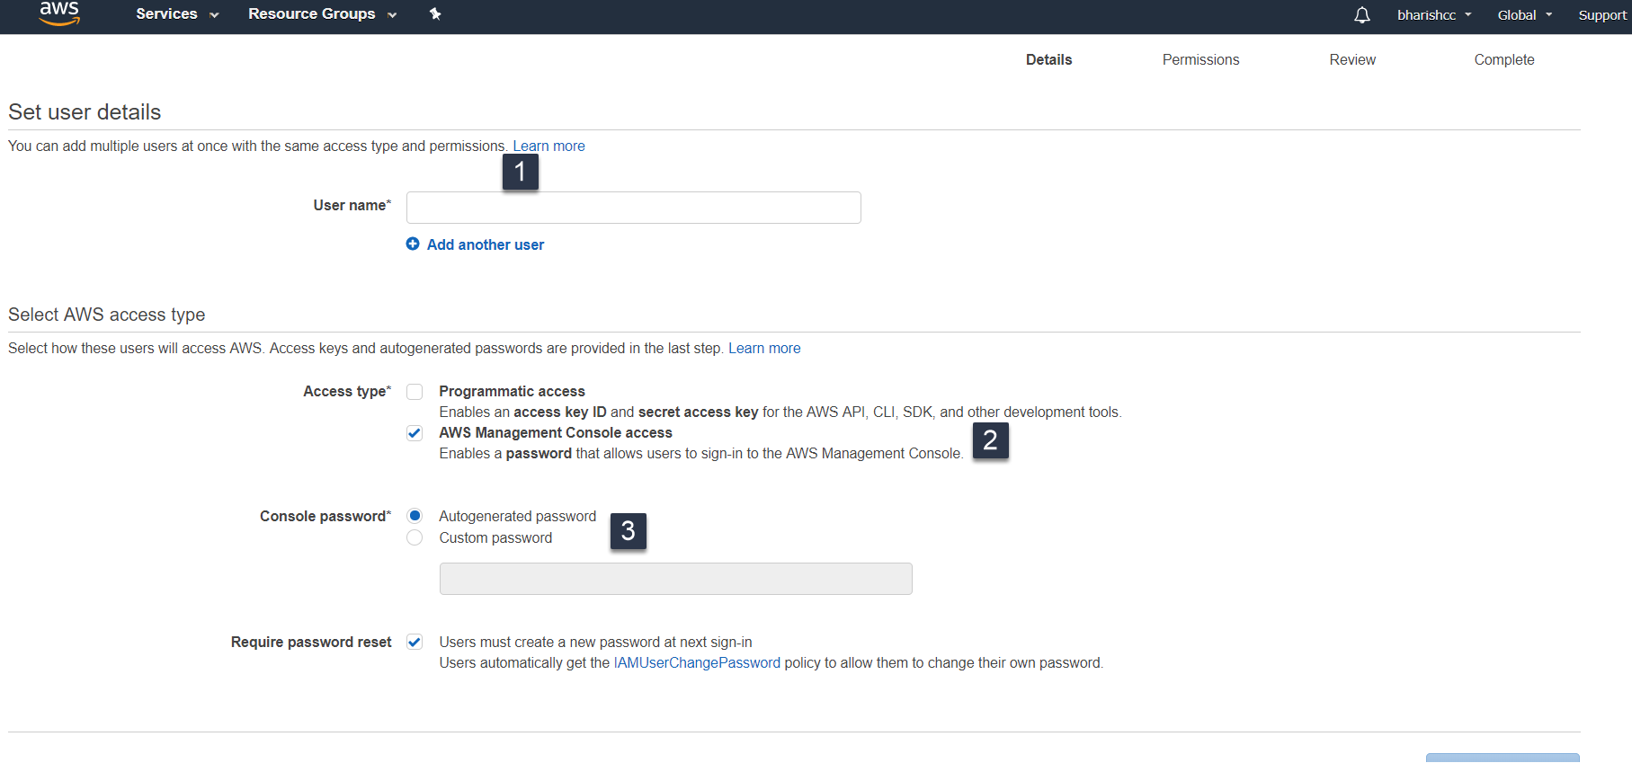

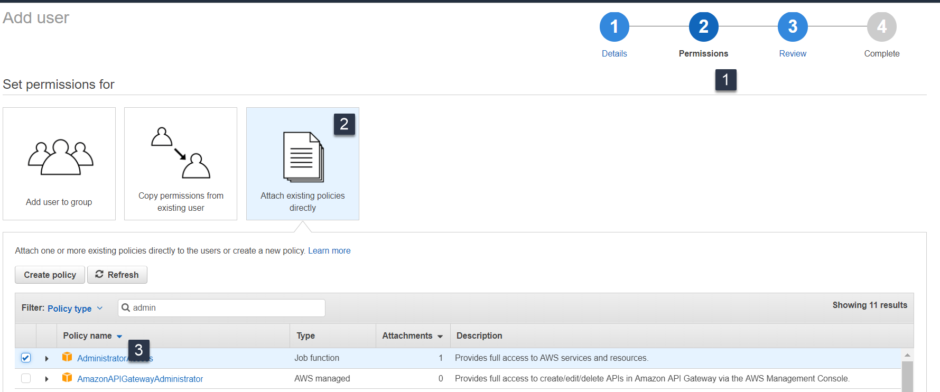

**c.) Use groups to assign permissions**

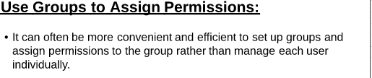

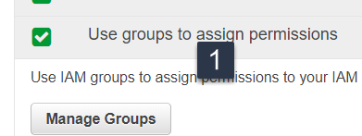 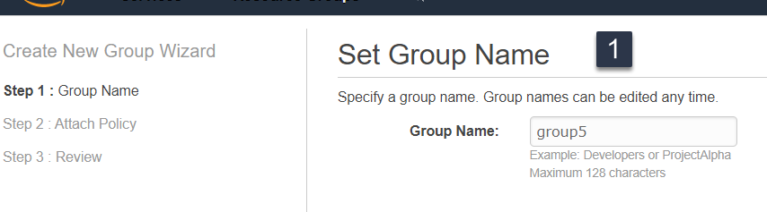 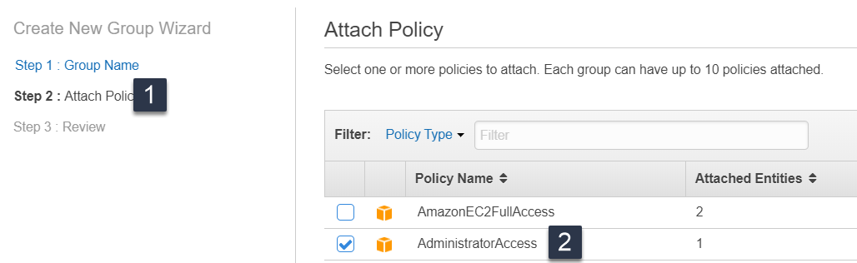

Now, we have created an Admin group group5

d.) **Apply an IAM password policy**

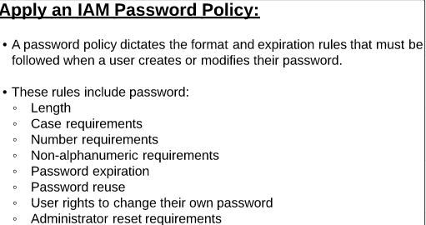

A password policy is a set of rules that define the type of password an IAM user can set.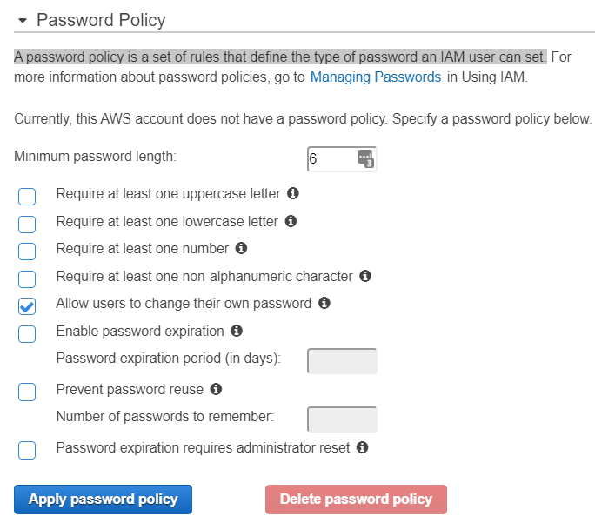

**--🡪3.) Users and Groups**

**Matt**

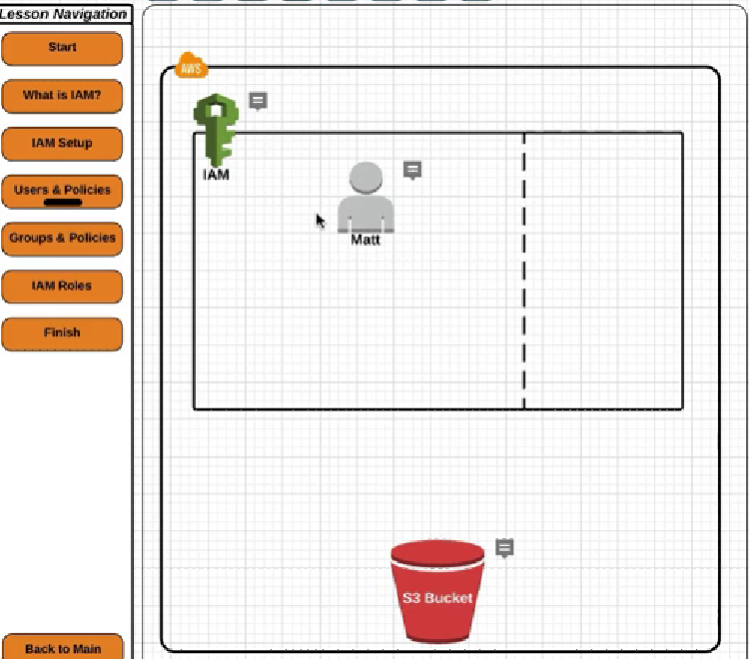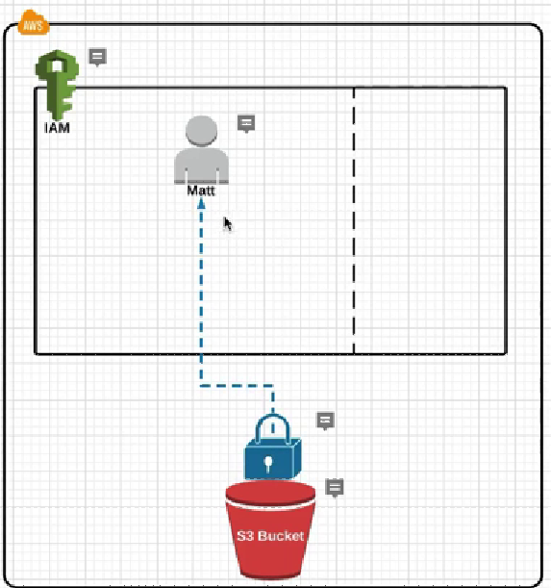 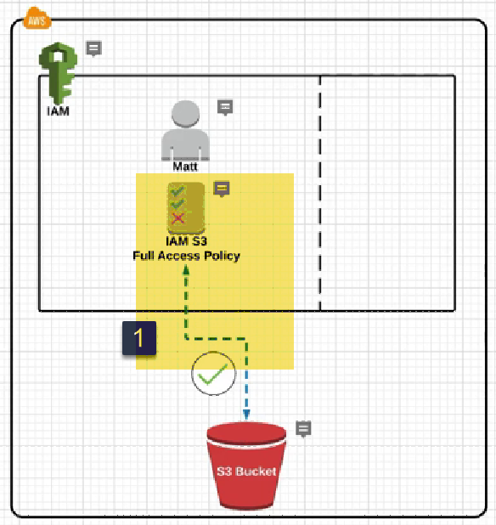

**TO assign policy to existing user**

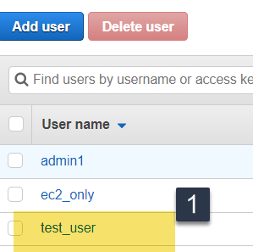(Click on User) 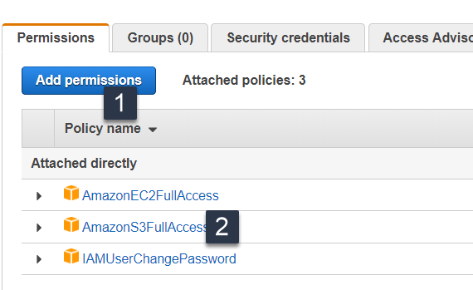(attach policy)

b.) Lets create account for DANA, KUNAL user accounts for Omega project Development team.

1.) Add users

2.) Attach policies for users

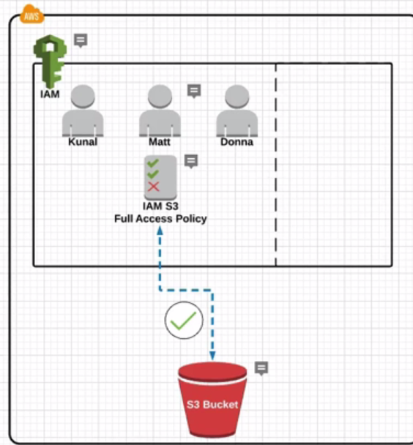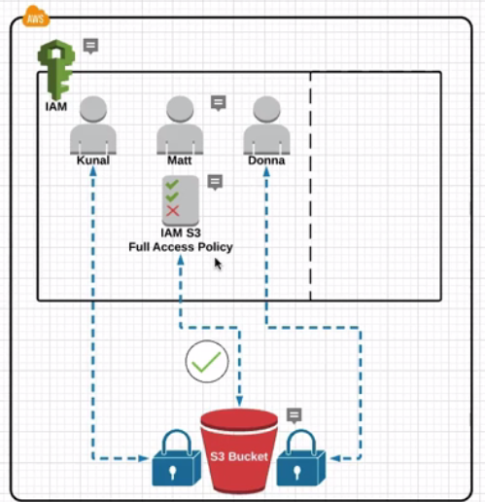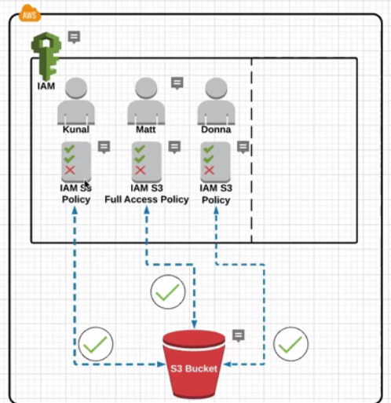

**Groups and policies**

Kunal , Matt, Donna individually accessed S3.

Detatch Policy for all 3 users ….

**Click on user:**   
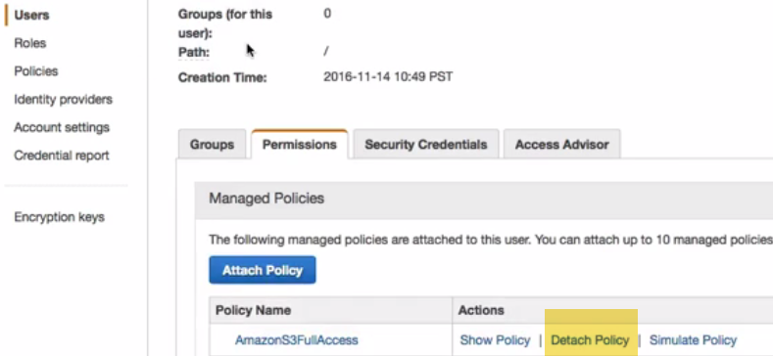

Now we have clean slide 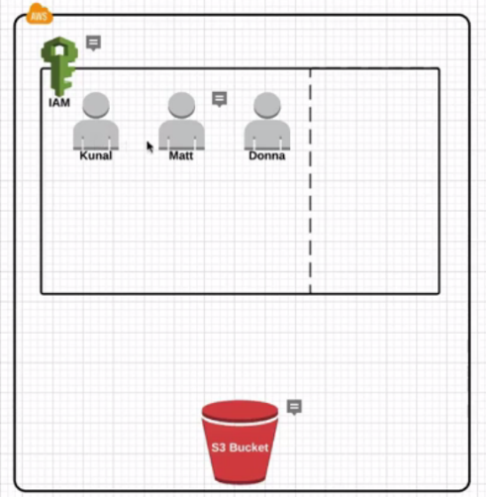 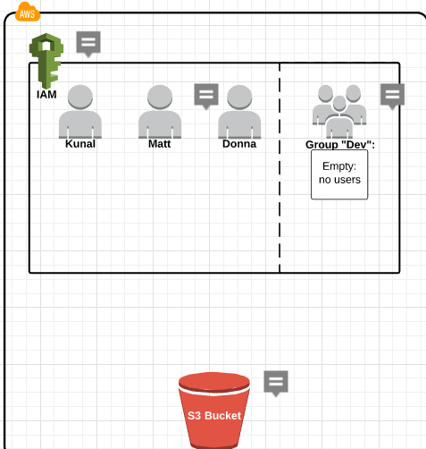

None have currently access to S3.Create New group Dev, and attach S3 policy later.

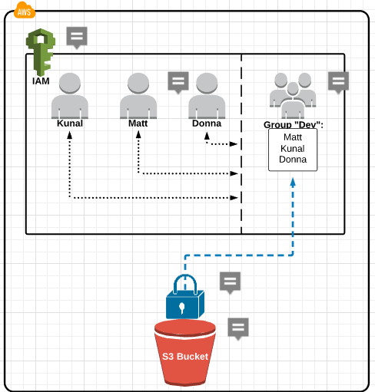 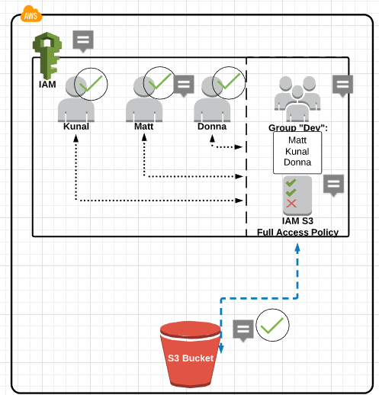

Create New group DEV..

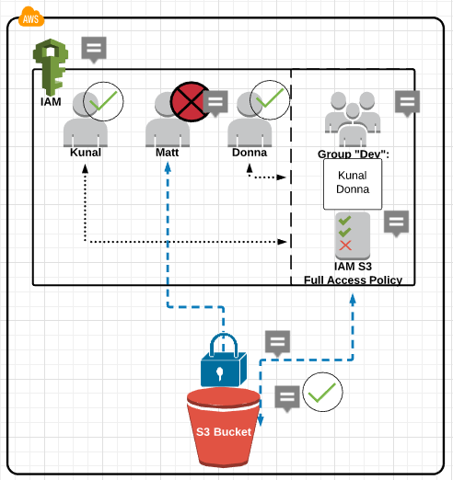 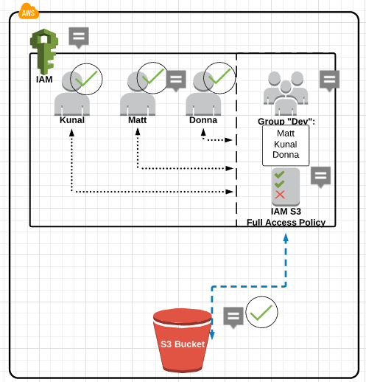

Roles

Kunal, Donna, Matt are users of group Dev. All have access to S3 because of policy attached to group.

Roles are bit different…

Let say we have EC2 instance., and software running on EC2 server.

And that software needs to access data/info on S3 bucket.

An AWS service needs to communicate with other AWS service.

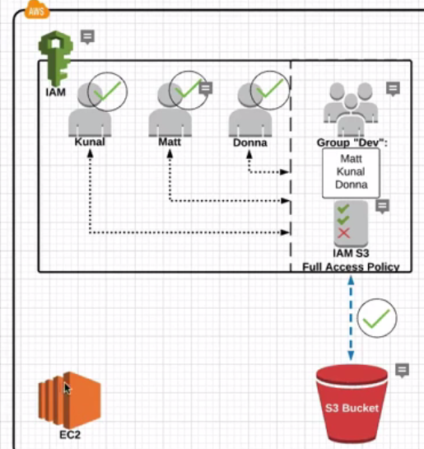 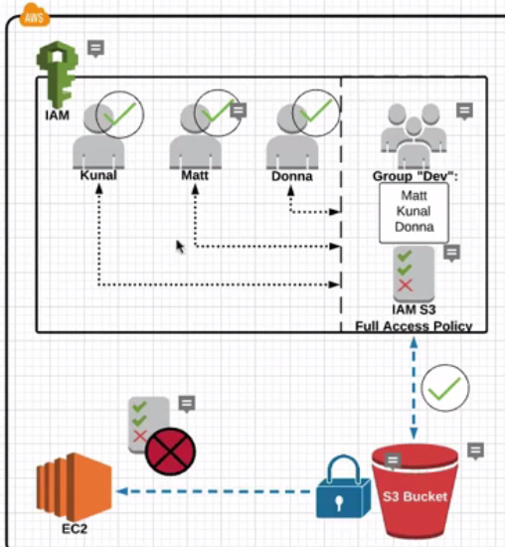

We may think, lets assign S3 policy and access S3 bucket.

But in AWS, we cant directly assign policies to other AWS services.First, we need to Attach role, and then to role can attach policy.

What role does is: It gives permissions to other AWS service to almost act as an User.

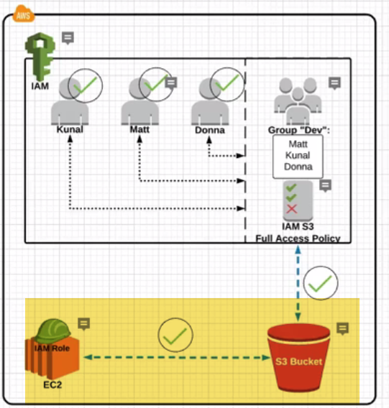

So, we can assign Role to Ec2 instance that has S3 policy attached to it. Thus Granting EC2 instance access to S3.

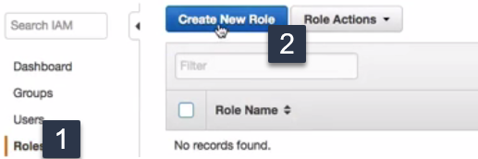

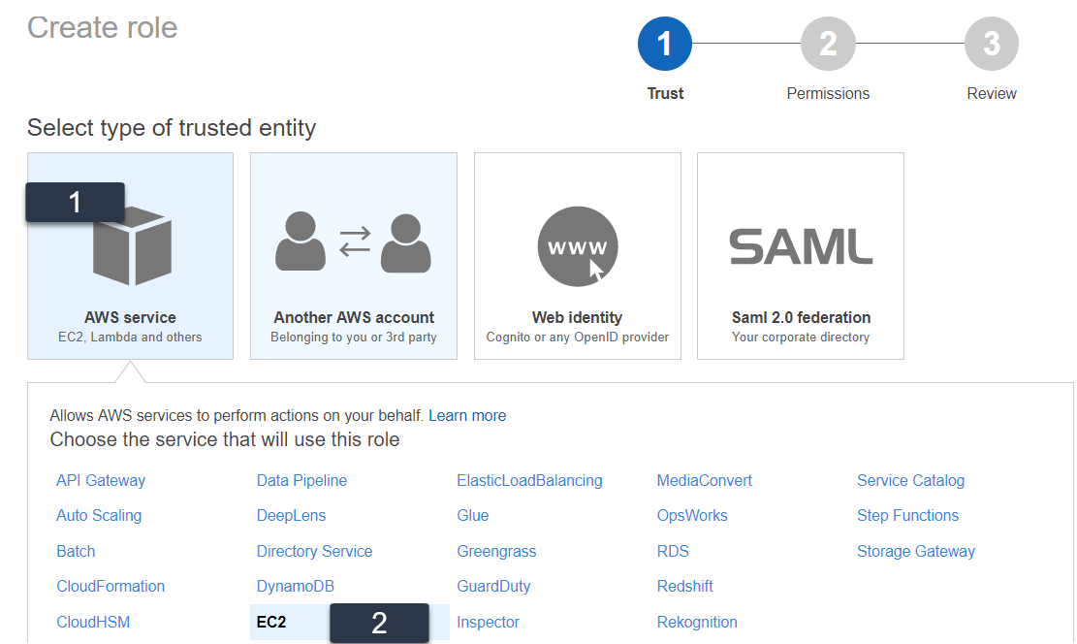 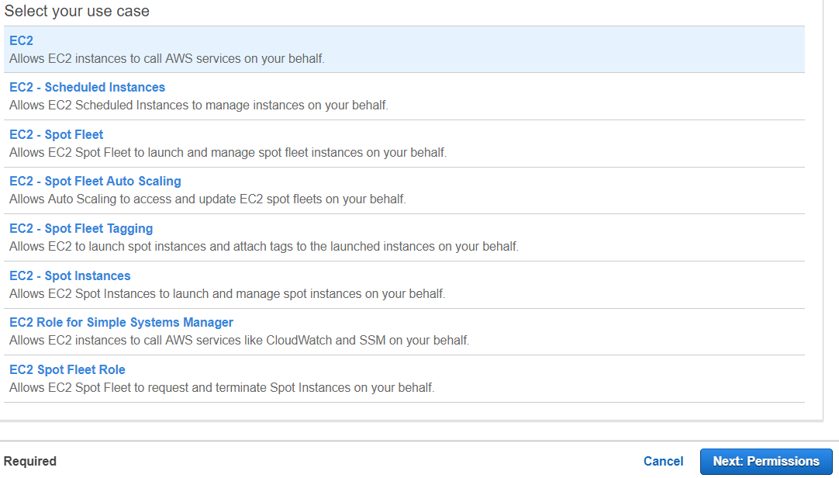

**We have to select EC2 service role.**

**Ex; If we are using Lamba and want to give AWS Lambda access to S3…You will create a Role and choose AWS Lamba to create the service role.**

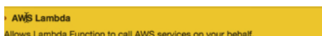

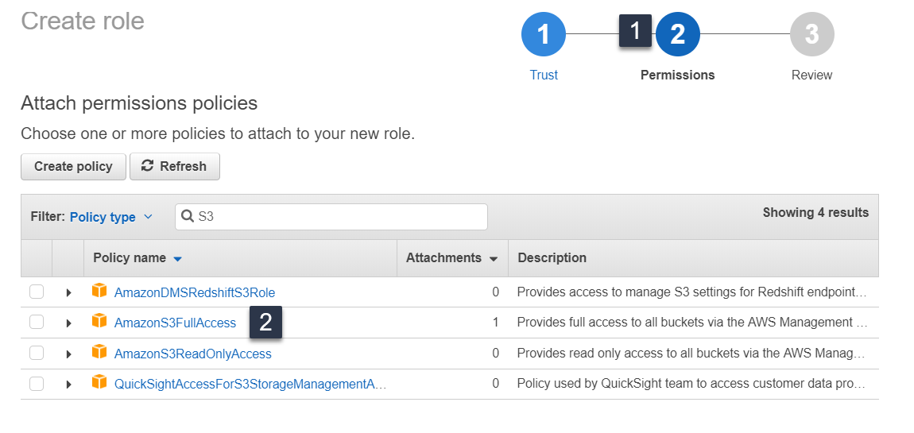

**We are going to assign S3 policy to EC2..Now, we can access S3 from EC2.**

**We can almost think Roles as groups ..But for AWS services other than Users.**

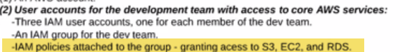

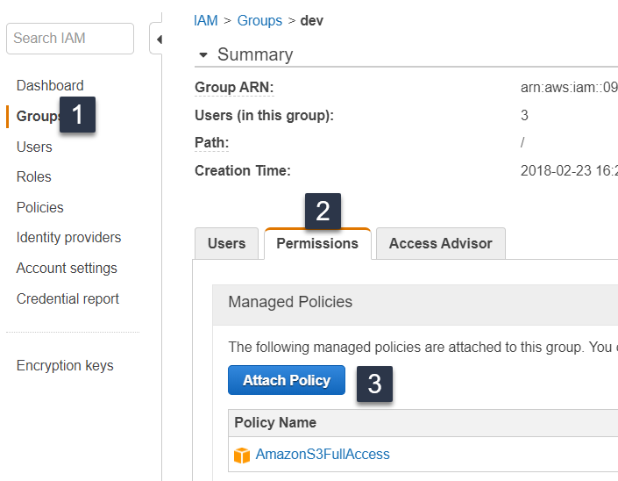

**It have S3 already attached. Now attach EC2, RDS policies.**

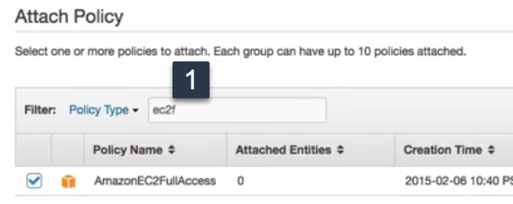 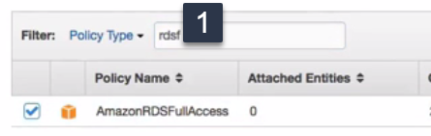

We can attach both Ec2, RDS policies at a time.

VPC

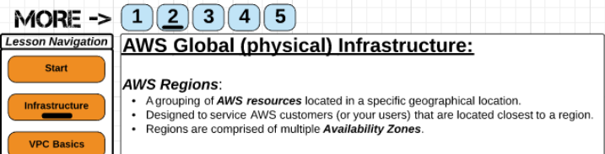

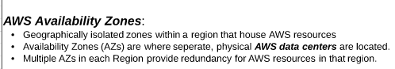

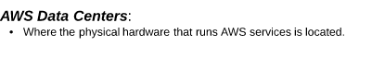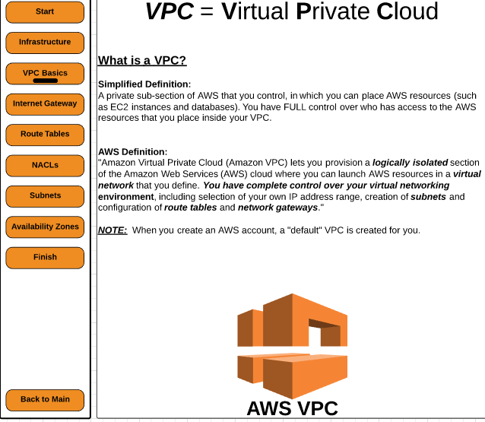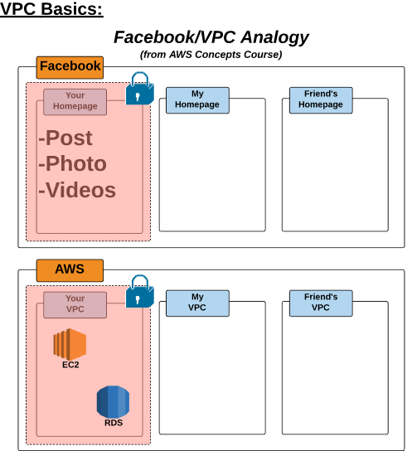

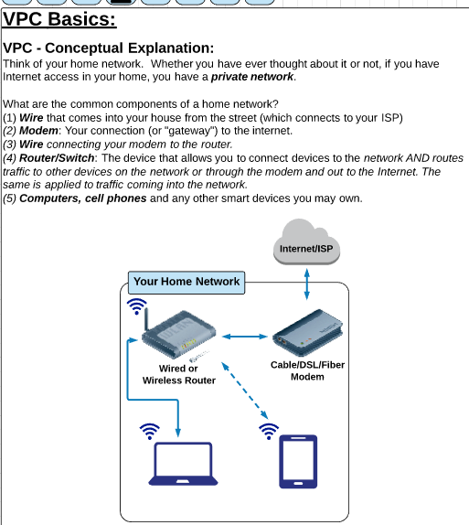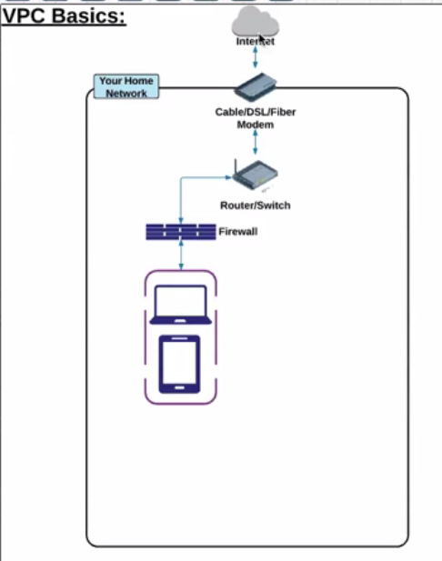

**EC2:**

